**Experiment No. 09**

* 1. **Experiment Name**

Load flow study using MATLAB Simulink platform

* 1. **Objectives**
* To become acquainted with the load flow study
* To understand the algorithm and generate a MATLAB code for load flow study
* To get familiar with the procedure of designing and analyzing a power system in MATLAB
  1. **Theory**

Hundreds of buses and branches with impedances specified per unit on a common MVA base make up the power system network. Power flow studies, also known as load flow, are critical for power system analysis and design. Load flow assessments are required for planning, economic operation, scheduling, and power exchange between utilities.

Load Flow analysis in the Simulink platform is simple thanks to the basic functions of the SimPowerSystemsTM toolbox.

* 1. **Required apparatus**
* MATLAB
* Simulink
  1. 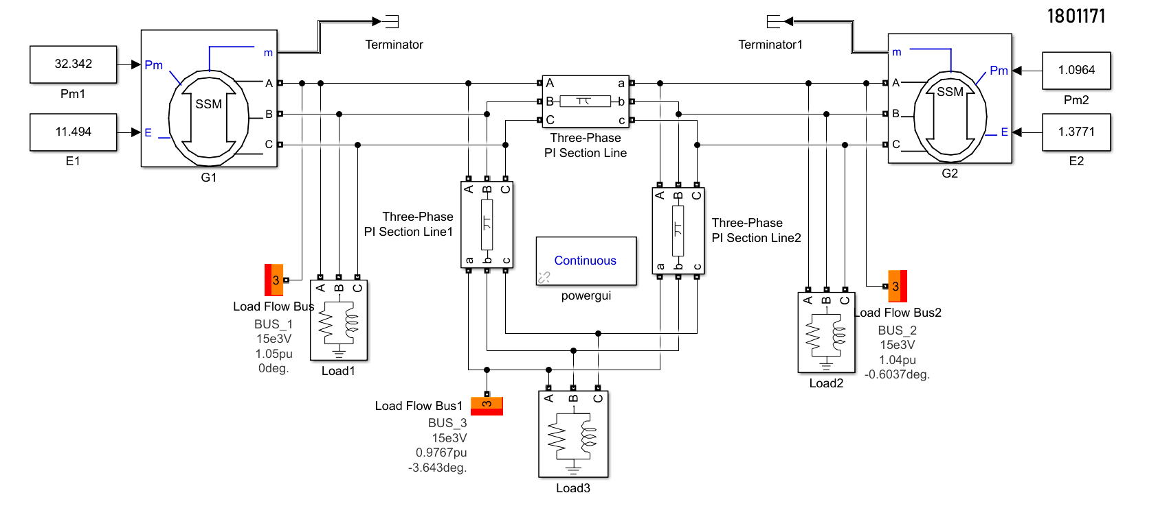**Block diagram**

Fig. 9.1: Circuit diagram for load flow study using MATLAB Simulink platform

* 1. **Load flow analysis report**



* 1. **Discussion & Conclusion**

The exercise taught us how to create a three-bus system in the Simulink platform using the SimPowerSystemsTM toolbox. We tweaked the parameters of the generators, loads, and transmission lines after developing it.

In the load flow analysis phase, we used PowerShell to evaluate the system. We studied the system and replaced the system's values with new values. The system's objectives were met with success.